**Exercise 1**

1. **What is Comput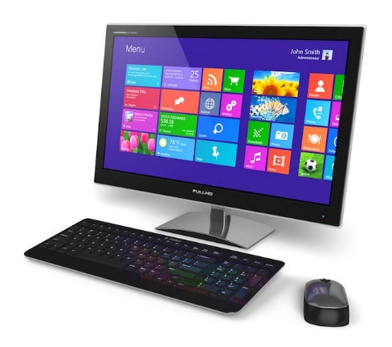er?**

A computer is an electronic device that processes data or information. Computers can be used in many ways, such as making documents, send and receive emails, browse the internet, and lastly, even play games. Computers made our daily tasks easier and more efficient to do compared from the past and made a great impact that is still evolving and changing overtime.

**2. What are the essential parts of computer?**

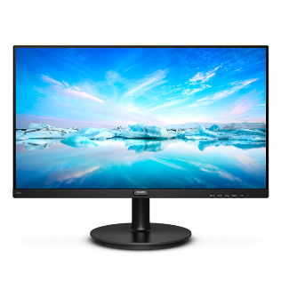

**Monitor**

A monitor is an electronic device that displays programs are running on your computer so a user can see.

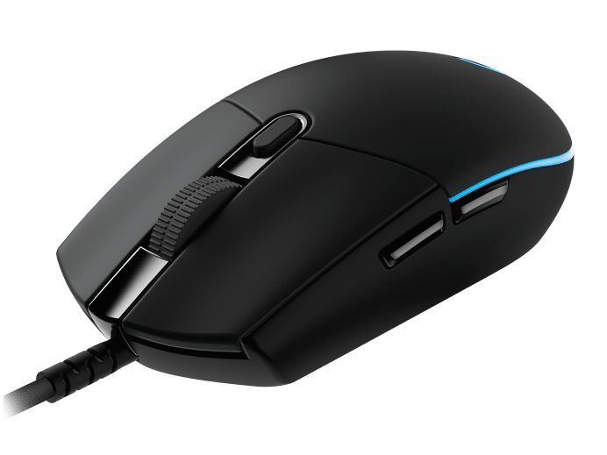

**Mouse**

A mouse is a part of a computer that is important so a user can drag, move, scroll the cursor. It is used to open and click programs.

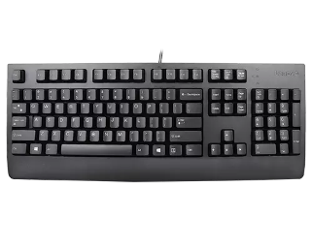**Keyboard**

keyboard is a part of a computer that is important so a user can type words into a document or a specific task.

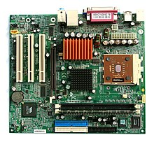

**Motherboard**

The motherboard provides the structure for all other components while also providing a way to distribute power, process information or data.

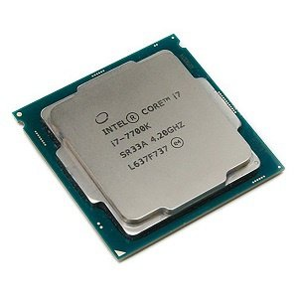

**CPU**

The Central Processing Unit (CPU) controls the computer processes and transmits with the other components of a computer.

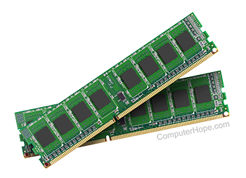

**RAM**

The Random Access Memory (RAM) is where data is being stored while it's being actively used by programs, such as when a user runs a computer application.

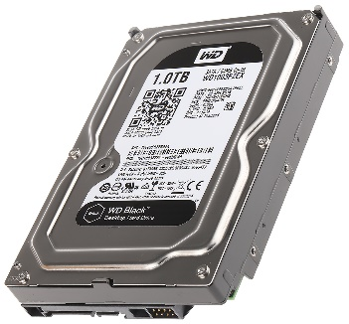

**Hard Drive**

Hard drives are data storage devices used to store files, programs or other information on a computer system.

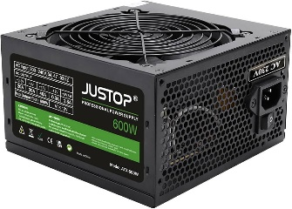

**Power Supply**

A power supply provides electricity to all components of a computer.

**3. Who are the notable inventors of hardware and software?**

**Software**



**Bill Gates**

Bill Gates is co-founder and the chairman of Microsoft, the world’s largest software company.



**Tim Berners-Lee**

Tim Berners-Lee is an English Developer who invented the World Wide Web in March 1989.

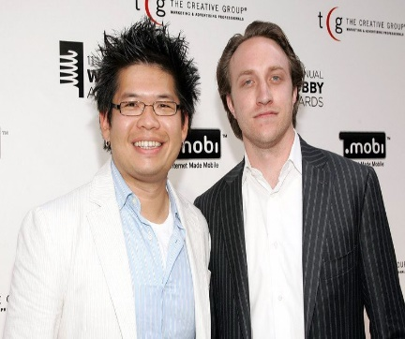

**Chad Hurley and Steve Chen**

Chad Hurley and Steve Chen developed YouTube, a video sharing website where users can upload, view and share video clips.

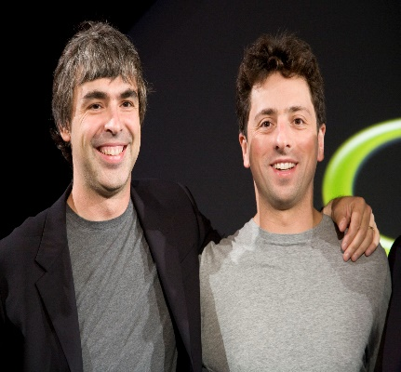

**Larry Page and Sergey Brin**

Ph.D. students at Stanford, Larry Page and Sergey Brin invented Google in 1996 as a research project.

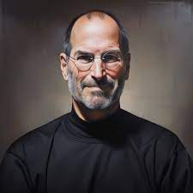

**Steve Jobs**

Steve Jobs is the CEO, chairman and co-founder of Apple Inc. and is the founder and former CEO of Pixar Animation Studios.  
  
  
  
  
  
  
**Hardware**

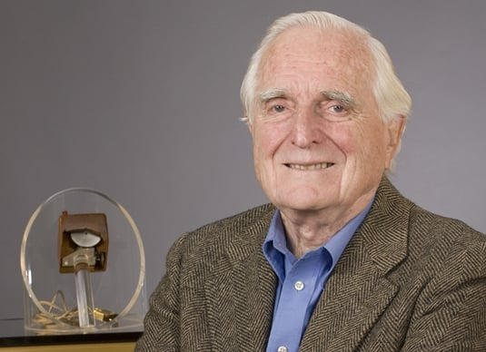

**Douglas Engelbart**

Doug Engelbart is known for his role in inventing the first computer mouse in 1968.

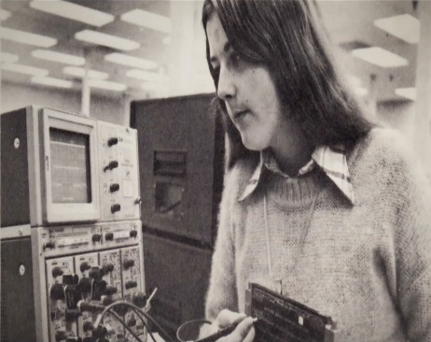

**Patty McHugh**

The first backplane to qualify as a motherboard was the Planar Breadboard designed by IBM engineer Patty McHugh and used in the 1981 IBM Personal Computer.

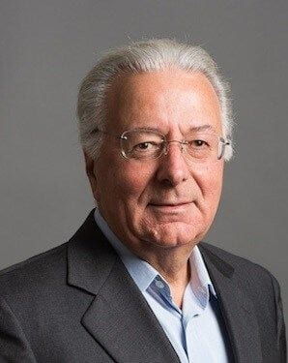

**Federico Faggin**

Italian physicist Federico Faggin invented the first commercial CPU. It was the Intel 4004 released by Intel in 1971.

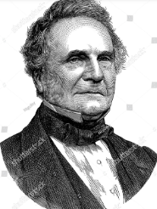

**Charles Babbage**

Charles Babbage was an English mathematician and inventor who is known for inventing the first automatic digital computer.

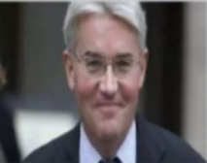

**James Mitchell**

The first true LED screen was developed by James Mitchell in 1977.

**4. Cite your reference/s**

GCF Global. (2019). “Computer Basics: What Is a Computer?” GCFGlobal.org

edu.gcfglobal.org/en/computerbasics/what-is-a-computer/1/

Indeed Editorial Team. (2023). “11 Basic Components of Computer Hardware: Tips for Technicians.” Indeed Career Guide

www.indeed.com/career-advice/career-development/what-are-basic-components-of-computer-hardware.

Mundi. (2023). “The 20 Greatest Innovators of All Time.” Www.startupmundi.com

www.startupmundi.com/the-20-greatest-innovators-of-all-time

Devtopics. (2008) “Top 10 Software Innovators of All Time.” DevTopics.com

www.devtopics.com/top-10-software-innovators-of-all-time/